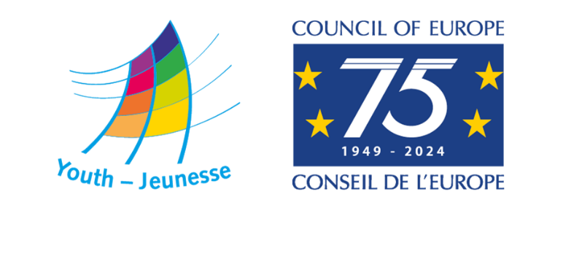

DDP-YD/ETD (2024) 25 Strasbourg, 30 January 2024

ROMA YOUTH TOGETHER 2024

A seminar on Roma youth empowerment and pride for the celebration of the International Roma Day

5-8 April 2024
European Youth Centre, Strasbourg

CONCEPT NOTE

CALL FOR PARTICIPANTS

Deadline: 25 February 2024

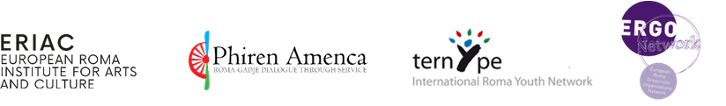
BACKGROUND
The Youth Sector Strategy 2030 of the Council of Europe aims to create spaces for young people to live together in peaceful and inclusive societies, with special emphasis on allowing young people, including those experiencing any form of discrimination and exclusion, to benefit from opportunities that develop their commitment to and exercise of democratic citizenship. It also emphasises the interest of the Council of Europe youth sector to develop a stronger profile regarding the inclusion of inter alia minorities and vulnerable groups, intersectionality, and inclusiveness across its programming.
The Council of Europe Strategic Action Plan for Roma and Traveller Inclusion (2020-2025) concurs in this priority by noting that:
Roma and Travellers, particularly women and youth encounter a variety of social barriers and prejudices that severely impede their capacity to effectively participate in public and political life. They are consequently largely absent from the local or national political arenas and decision-making processes affecting them. This invisibility undermines their potential to reverse embedded marginalisation and discrimination.
The Action Plan also recognises that there can be several – intersecting - grounds for discrimination at play in a given case and that unfortunately, neither the concept of multiple discrimination nor intersectionality have yet been integrated into legal remedies, policy making or data collection.
In their Youth Statement issued on the occasion of 8 April 2021, the participants in the first conference Roma Youth Together call on the Council of Europe member states to seek active dialogue with Roma youth organisations and to ensure lasting mechanisms of empowerment and participation of young Roma. These calls result from the fact that many Roma youth continue experiencing multiple discrimination, or live in specific situations of vulnerability, with impact on their social inclusion and lower levels of participation in society.
On 5 April 2023, the Committee of Ministers adopted the Recommendation CM/Rec(2023)4 on Roma Youth Participation, urging member states of the Council of Europe to prioritize the substantive, fair, and systematic involvement of young Roma individuals in various societal aspects and decision-making processes. The recommendation emphasizes the need to integrate the expressed needs and priorities of young Roma people into all relevant policies and programs, assess existing policies for potential redesigning to enhance Roma youth participation, combat structural anti-Roma racism, ensure the full realization of fundamental human rights for young Roma, support Roma youth-led organizations and initiatives, and more.
The Recommendation was adopted because young Roma people face systematic discrimination in their access to social, economic, cultural, political and civil rights, and that structural racism negatively impacts Roma youth’s participation in civic and political processes and structures, self-esteem, pride and well-being, their transition to adulthood, their trust in the fairness of institutions, and their readiness to embrace their roots and cultures.
ROMA YOUTH TOGETHER – 8 APRIL
The Council of Europe (Youth Department and Roma and Travellers Team) has been marking the International Roma Day by, inter alia, bringing together Roma youth organisations and young people at the European Youth Centre to celebrate and put together their concerns and aspirations. This took the form of an online conference in 2021, Roma Youth: Together for Emancipation and Empowerment, and two residential seminars in 2022 Roma Youth Together - seminar on Roma youth participation and empowerment, and 2023 Roma Youth Together - seminar on Roma youth participation and intersectional discrimination.
In 2024 this will continue by focusing on youth participation and empowerment of Roma youth, including Roma girls and women, young Roma LGBTI and Roma migrants. As in previous years, the activity will be co-organised with the European Roma Institute for Arts and Culture (ERIAC), the International Roma Youth Network - TernYpe, the European Roma Grassroots Organisations (ERGO) Network and Phiren Amenca.
The seminar Roma Youth Together 2024 will bring together young people who are youth leaders and/or youth workers in Roma and Travellers communities and organisations across Europe. The seminar will take place in the European Youth Centre in Strasbourg, France, from 5 to 8 April.
AIMS AND OBJECTIVES
The seminar aims at empowering Roma youth leaders from across Europe to realise their potential through positive actions and narratives celebrating Roma identity and cultural diversity on the International Roma Day. Its specific objectives are:
- to share experiences and realities of Roma youth across Europe, especially in relation to meaningful youth participation;
- to empower Roma youth and Roma civil society to act as agents of change and multipliers in their communities;
- to support participants’ potential for expression of cultural identity and pride, action and visibility, both online and offline;
- to associate young Roma with the Council of Europe’s work in the field of Roma youth participation, namely in the light of the 75th anniversary of the Council of Europe;
- to celebrate International Roma Day with Roma youth as front-runners in shaping it;
- to strengthen the sense of Roma youth community and connect with European youth organisations and networks in the field of Roma participation.
PROGRAMME AND METHODOLOGY
The methodology of the seminar will be based on the principles of human rights education, peer to peer learning, exchange of practices and dialogue among participants by using the participatory methods of learning, such as working groups, creative workshops and facilitated discussions. It will be structured in connection to the previous work done by the Council of Europe in the area of Roma youth participation.
Specific of the 2024 event is the focus on celebration of creativity, co-creation and expression as a form of celebrating the International Roma Day. This will take the form of workshops during which participants will share talents and put their creativity and aspirations in forms of cultural expressions such as media and visual arts, music, danse or plastic arts. The programme will thus be built on participants’ experiences, interests, and inputs with an emphasis on sharing and co-creation.
There will be three main and interconnected phases of the programme:
- Share: discussing achievements and good practices from the Roma youth communities across Europe and the related approaches of the Council of Europe and priorities of Roma youth organisations which support Roma youth participation;
- Create: putting together resources, skills, and knowledge to co-create narratives and content that promote Roma identity, heritage, and culture, and establishing working groups focussing on strategies to address anti-discrimination online and offline, and connection with youth policies and programmes.
- Celebrate: preparing and partaking in the programme for the celebration of the International Roma Day.
PROFILE OF PARTICIPANTS
The seminar is designed for Roma young people, youth leaders or youth workers in Roma communities, representatives of organisations and networks working with Roma communities from across Europe. Participants should also be:
- Aged between 18 and 30;
- Motivated to meet and develop cooperation with other Roma youth;
- Active within a Roma organisation or a (Roma) youth organisation or community or informal group;
- Committed to act as multipliers for empowerment of Roma youth;
- Motivated to share experiences and engage in dialogue and cooperation with other participants in the seminar;
- Able to attend the whole seminar and all its programme elements;
- Able to work/communicate in English.
Priority will be given to participants who have not attended previous editions of Roma Youth Together seminars or similar activities of the Council of Europe.
The Council of Europe (and partners) welcomes applications from all candidates who fulfil the above-mentioned competences profile, irrespective of gender, disability, marital or parental status, racial, ethnic, or social origin, colour, religion, belief or sexual orientation.
FINANCIAL AND PRACTICAL CONDITIONS
Travel expenses
Travel expenses and visa fees for travelling to Strasbourg will be reimbursed according to the rules of the Council of Europe. Only the participants who attend the entire seminar will be reimbursed.
Accommodation and meals
Board and lodging for the seminar will be provided and paid for by the Council of Europe at the European Youth Centre in Strasbourg. The venue is accessible to people with disabilities and can take measures to accommodate for specific needs of participants in this respect.
Working languages
The main working language of the programme will be English with the possibility for usage of Romany where needed.

FURTHER INQUIRIES
For more information about the seminar and for technical assistance with the application form uploaded at the Council of Europe Youth Department platform, please address: eyc.programme@coe.int.

PROCEDURE FOR APPLYING FOR PARTICIPATION
Applications must be submitted by Sunday, 25 February 2024, 23:59 CET by completing the online application form available at: https://youthapplications.coe.int.
Other activities of the Youth Department of the Council of Europe
If you are interested in a training course in international youth work, but your profile does not fully correspond to the requirements of this activity, please note that the Youth Department of the Council of Europe also organises other study sessions, seminars, and training courses with and for young people. For more details, please consult our webpage www.coe.int/youth or contact one of the European Youth Centres in Strasbourg or Budapest.

____________

